**ASSIGNMENT FOR : Drupal 8: front-end & Backend**

**1.Install fresh drupal with virtual host "local.[YOUR-NAME]recipes.com" (e.g local.amanrecipes.com)**

**Answer 1:**

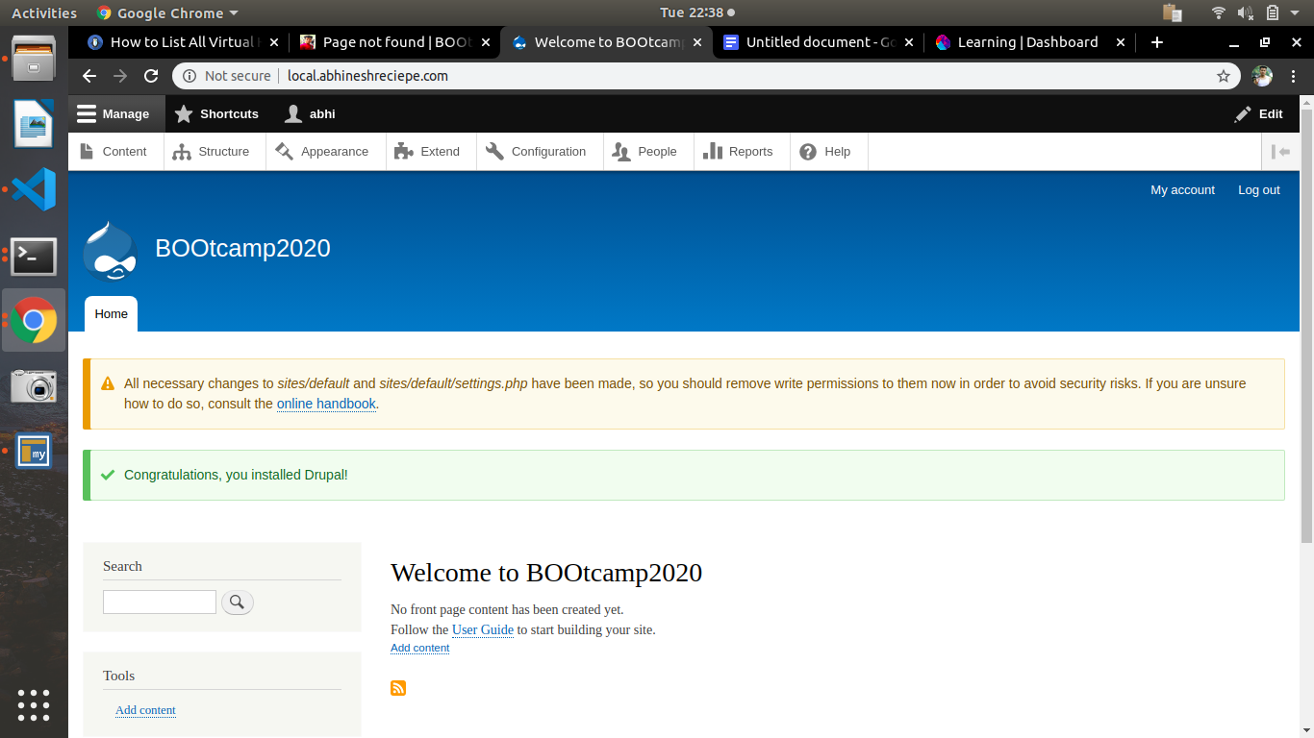

**2.Upload a new logo for the site and update site-name.**

**ANSWER 2:**

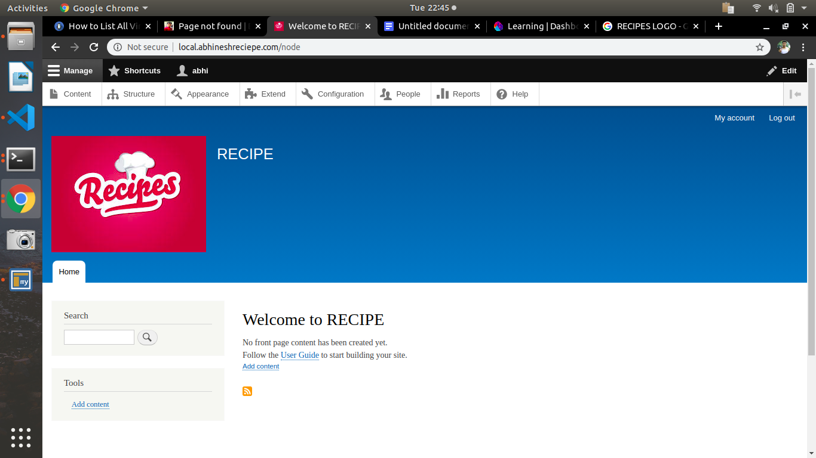

**3.Create two vocabularies :**

**a.Ingredient (pasta/noodles etc)**

**b.Cuisine (italian/chinese etc)**

**ANSWER 3:**

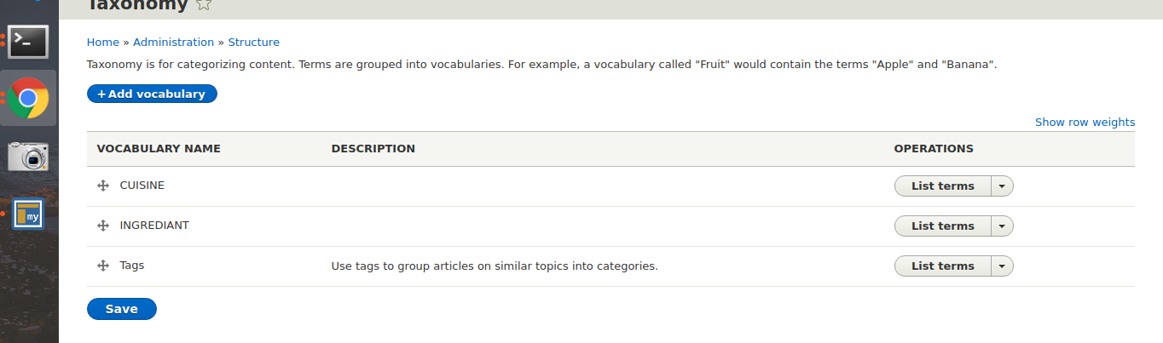

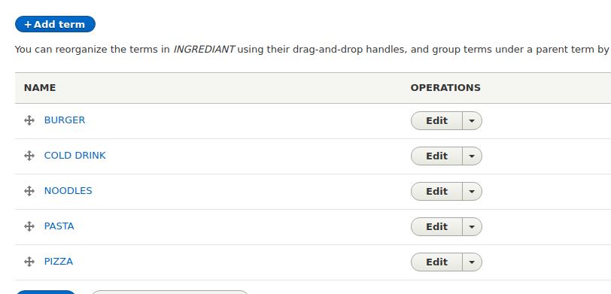

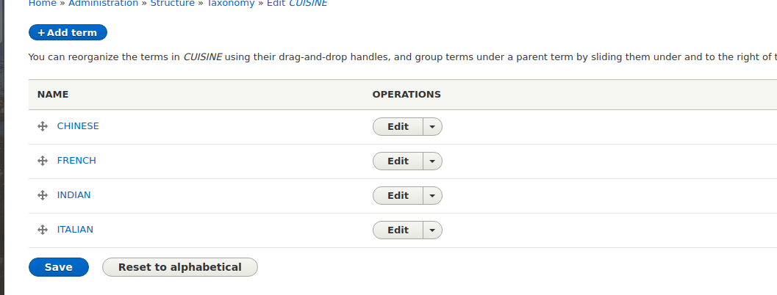

**4.Add following fields in user account :**

**a.Full name**

**b.Phone no**

**ANSWER 4:**

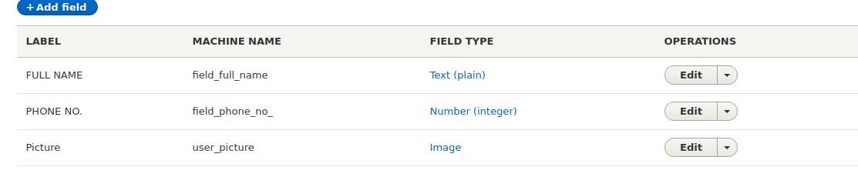

**5. Create role "Publisher" and 2 users for this role.**

**ANSWER 5:**

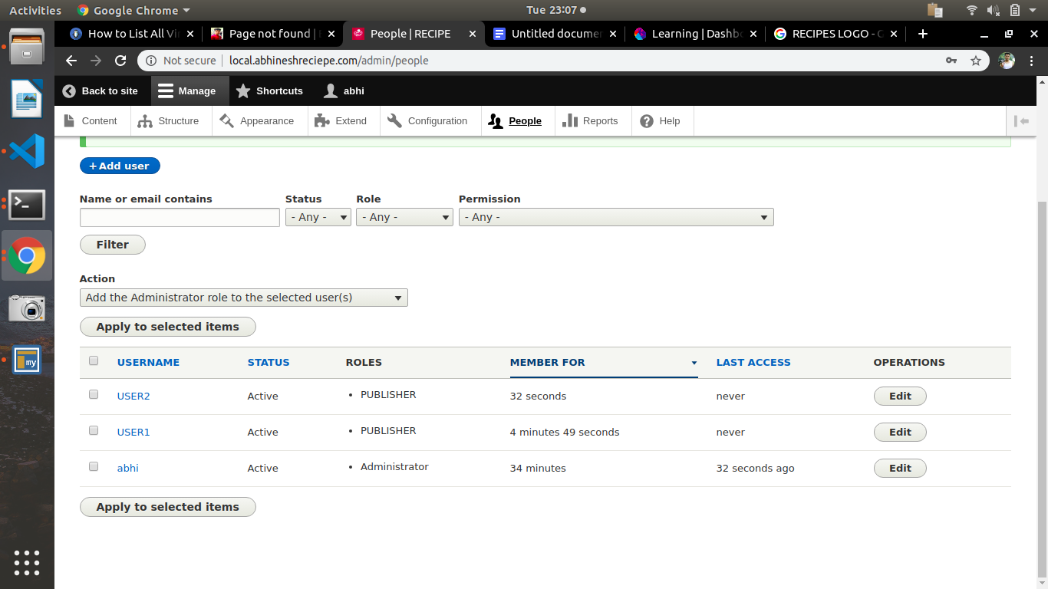

**6.Create create content type named as "Recipe" with following fields :**

**-Directions (body field)**

**-Cuisine Type (Use the Cuisine type vocab here)**

**-Ingredients (Use the Ingredient vocab here with unlimited values)**

**-Veg/Non-Veg? (Radio button field)**

**-Images (2 images allowed)**

**-Publisher (User reference field)**

**-Comment**

**ANSWER 6:**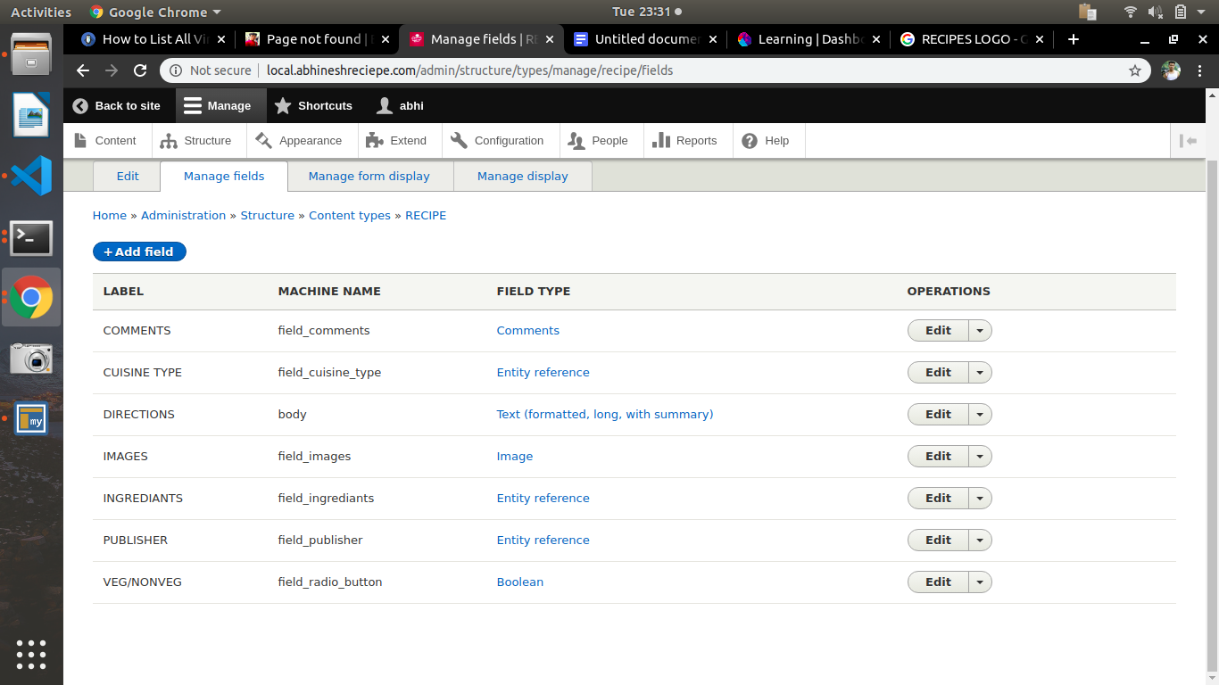

**7.Create 4 recipes(nodes) using above content type with url alias**

**ANSWER 7:**

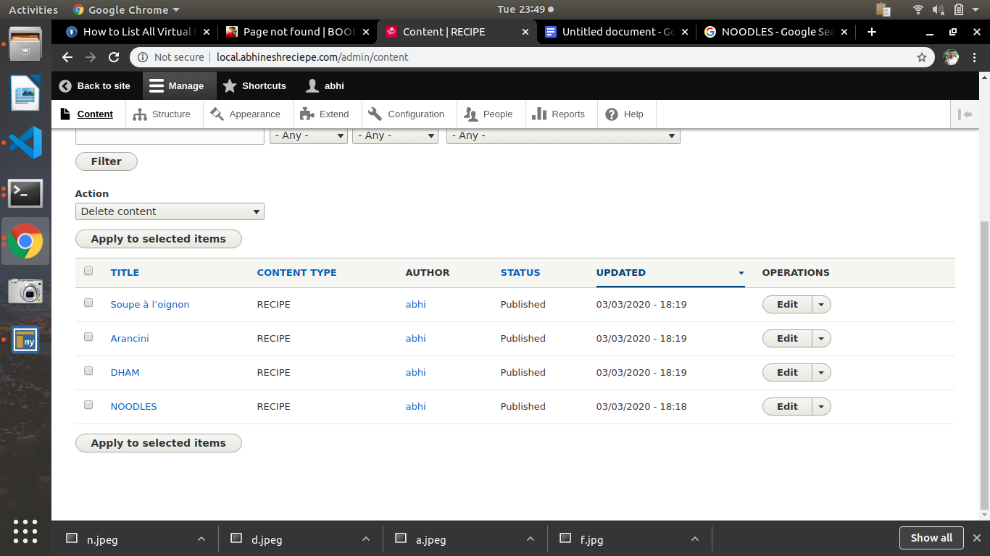

**The way i created alias for the recipe ,i created for others three**

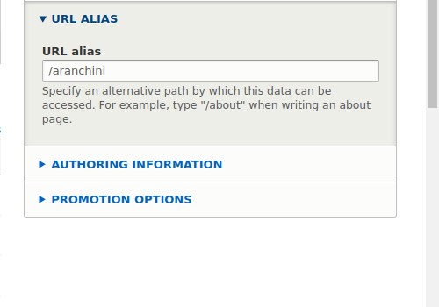

**8.Create a menu named “Recipe List” and add links of the recipes.**

**ANSWER 8:**

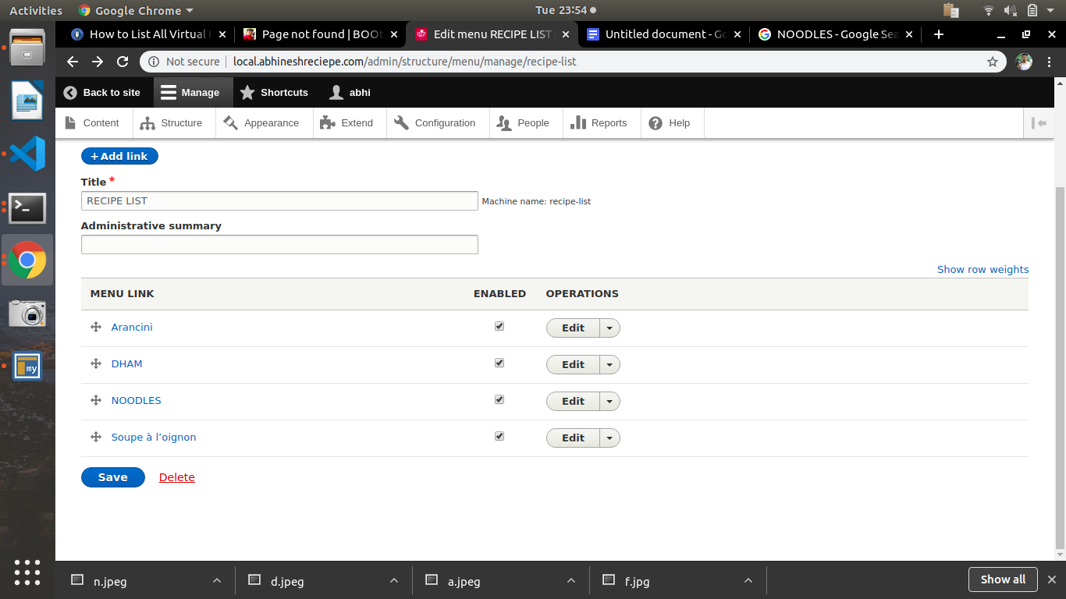

**9.Place above created menu in Sidebar region.**

**ANSWER9:**

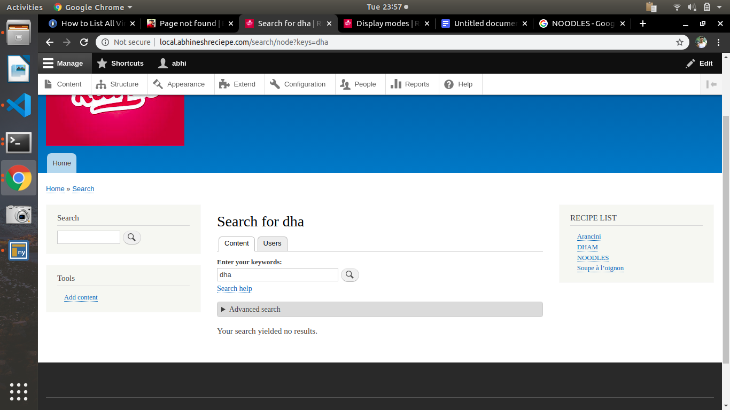

**10.Create a custom block for copyright and place in footer region.**

**ANSWER 10:**

